Dummy Solver in aaBridge - a How to use

The free aaBridge (which runs on Windows, Mac's and Linux) is available from
http://rogerpf.com/aaBridge
Now includes its own Double Dummy Solver (DDS) courtesy of Bo Haglund.

How to use the DDS
In aaBridge open any deal, including one of your own if you have it to hand or follow along with this built in example.
On the aaBridge - Welcome Page - (in the left-hand column) click on the entry "1957 Bermuda Bowl". A table, of four columns, showing the boards played in that session will appear. Click the entry in the 1st column which has the text "217".

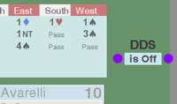
Now, no matter how you loaded the file - Click on the "Enter the Deal" button.
Avarelli is defending in 4 Spades.
To active the DDS Click where it says "is Off" and the DDS will turn on and show a new buttoned marked "Analyse".
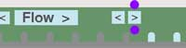
An aside - Mouse wheel - After clicking the 'single forward arrow' button you do not need to kick it again. Just use the mouse wheel. This will do (both forward and reverse) of which ever of the three main movement buttons you last clicked.
- Step, Flow or 'single forward arrow'.
As you click the 'single forward arrow' button the play of the cards will be displayed to you as normal.
In addition you will see small numbers against some of the cards in the hand that could be played next.
<end of page>
At the start of trick two, Koytchou has to find the Queen of Spades (trumps).
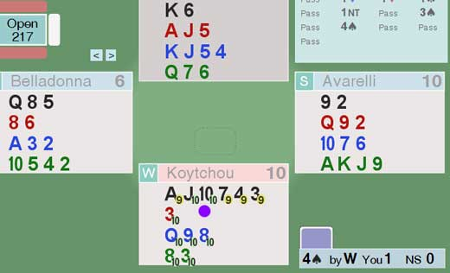
The two small number 10's, each in a green oval, mark the cards that will kill the Queen. If he leads any other spade then he can only make 9 tricks. The DDS tells you this is by marking the other spades each with the number 9 in an amber oval.
Assuming the perfect play from both sides then the numbers in a green oval show plays that cannot unnecessarily lose a chick.
Of course in real life we don't play bridge double dummy so it often not possible to make perfect plays. The DDS is there to give you insight at review time into things you might have missed such as squeezes and end plays.

<end of page>

The all Contract Analyser
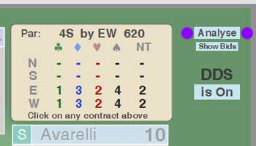

When you click on the Analyse button the bidding area is replaced by a contract table.
The top line shows the par contract and its score.

The columns of the table show the level of make-able contract in every denomination for every player.

If you click on any of the entries, including the hyphens, you will be taken to that contract and will be there able to use all the normal aaBridge functions of playing and examining the contract with, for example, with the DDS.

Last Thought
If you're wondering which card Koytchou actually played then all you have to do is to follow the link at the start of this document, install aaBridge and see for yourself. :)

<end of document>

